To install Apache Maven 2.2.1 on Ubuntu 12.04, take the following steps:
- Get Maven 2.2.1 binary distribution using the following command:
wget http://mirror.nexcess.net/apache/maven/maven-2/2.2.1/binaries/apache-maven-2.2.1-bin.tar.gz

- Unpack the binary distribution using the following command:
tar -zxf apache-maven-2.2.1-bin.tar.gz
- Move uncompressed "apache-maven-2.2.1" directory to the /usr/maven directory using this command:
sudo cp -R apache-maven-3.0.4 /usr/maven/apache-maven-2.2.1
- Create a symbolic link to /usr/bin using the following command:
sudo ln -s /usr/maven/apache-maven-2.2.1/bin/mvn /usr/bin/mvn
- Verify for correct installation using the following command:
mvn –version

- It should print the following information:
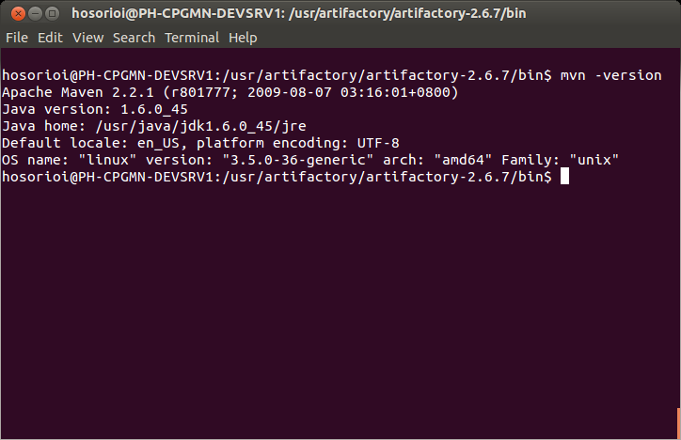
- Create environment variable M2_HOME and point to your maven installation. This will be used in succeeding integration effort.

